**Design of a Car Rental System**

NOTE: Code for insertion of tables are included on GitHub

**ER Diagram:**

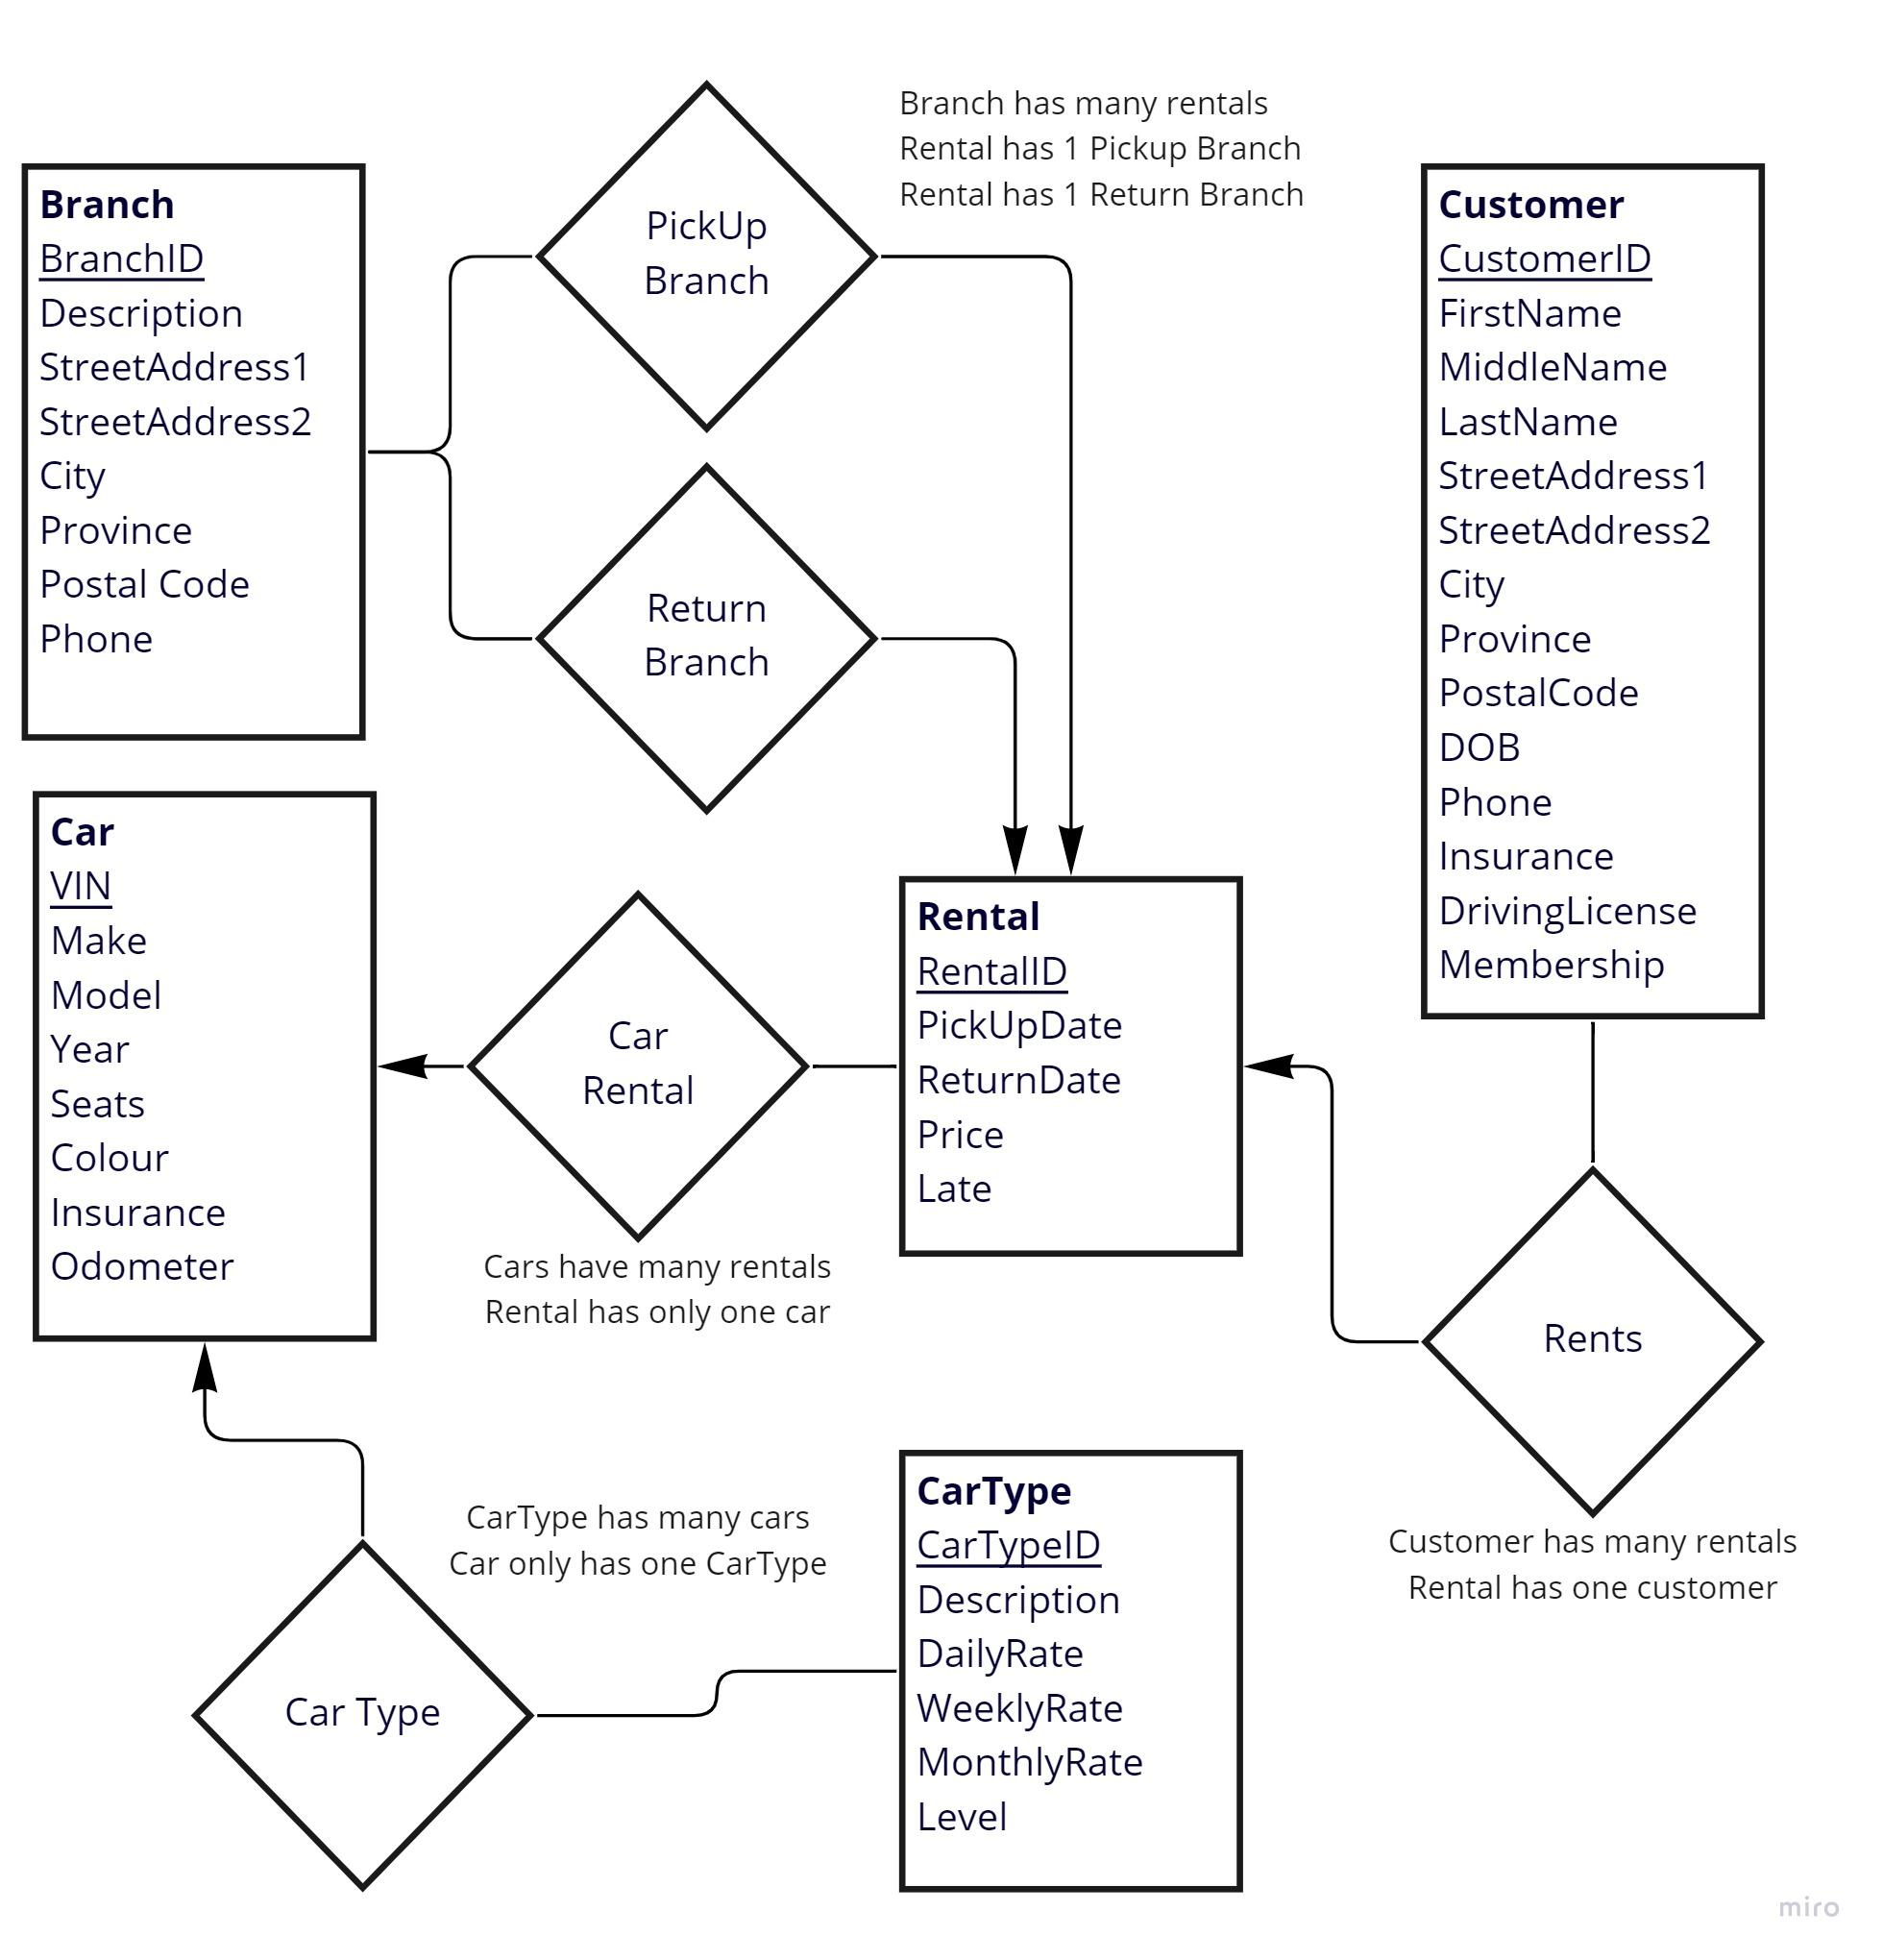

**Tables:**

Branch = BranchID, Description, StreetAddress1, StreetAddress2, City, Province, Postal Code, Phone

Car = VIN, CarTypeID, Make, Model, Year, Seats, Colour, Insurance, Odometer

CarTypeID FK references CarType

CarType = CarTypeID, Description, DailyRate, WeeklyRate, MonthlyRate, Level

Customer = CustomerID, FirstName, MiddleName, LastName, StreetAddress1, StreetAddress2, City, Province, PostalCode, Phone, DOB, Insurance, DrivingLicense, Membership

Rentals = RentalID, PickUpBranchId, PickUpDate, ReturnBranchId, ReturnDate, CarTypeID, CustomerID, VIN, Price, Late

PickUpBranchId FK references Branch

ReturnBranchId FK references Branch

CarTypeID FK references CarType

CustomerID FK references Customer

VIN FK references Car

**Explanation:**

* BranchID, CarTypeID, CustomerID, & RentalID are all automatically assigned, incrementing by 1.
* In CarType, Level refers to the precedence order of the CarTypes. This is included to allow reordering of CarType precedence. If we just used the primary key, then each CarType would need to be reentered when the precedence changes, such as when a new CarType is added.
* In Customers
  + Membership is an integer of 0 or 1. 0 Indicates standard membership, 1 gold membership
  + Membership is entered by use of a checkbox so that the user can’t enter anything other that 0 or 1
* In Rentals
  + CarTypeID is included in Rentals for ease of calculating price and to ensure that CarType is recorded in case of change of CarType of the car later on.
  + Late begins as 0 and is changed if, when a rental is completed, the customer returns the vehicle after the original return date.
* All phone numbers are parsed before entry into the database so that only numeric values remain
* All values that must be integers in the database have checks to ensure they are entered as such
* We used drop down boxes for any entry that would be chosen from data in the database. Such as CarTypeID when entering Cars and BranchID when entering Rentals
* Any box that is preceded by a Find button requires that the user pre-search for the ID they are looking for and copy/paste the ID they wish to use into the FindD box. This is the VIN in the Car Entry form
  + This is not ideal, but is a limitation of our system. It is noted in the User Guide.
* Add, edit, remove, search (and complete for transactions) are done in the same screen by using radio buttons.
  + Search results are then shown on the main page for each type of table
* All string values are made to have the first letter of each word capitalized, except for those in which capitalization may make sense. Such as postal code, Vin, driving license, etc.